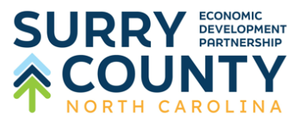 | Investment  Pledge  Form

Name:
Company:
Address:
Phone Number:
Email Address:
To strengthen the Surry County economy by supporting Surry County Economic Development Partnership’s mission to provide a network of coordinated resources for economic development that will grow, support, and maintain the well-being of the communities, businesses, and investors of Surry County, we hereby authorize and commit the following investment towards these five-year initiatives:
Total 5-year Pledge: $_____________________
Initial Payment: $ _____________________
Payment 2: $ _____________________ Annual: Yr: 2026
Payment 3: $ _____________________ Annual: Yr: 2027
Payment 4: $ ____________________ Annual: Yr: 2028
Payment 5: $ _ ____________________ Annual: Yr: 2028
Signature: ___________________________________Date: ___________________________
Preferred billing reminder month: _____________________________________
Contact for invoicing: Name: ______________________ Title: _________________________
Email Address ________________________________________________________________
Direct Phone Number: __________________________________________________________
Address: _____________________________________________________________________
*Surry County Economic Development Partnership a 501(c)6 non-profit organization and your support may be treated as a necessary and ordinary business expense.*
Please scan and email to:
blake@surryedp.com
Or Return Completed Form To:
Surry County Economic Development, P.O. Box 7128, Mount Airy, NC 27030

