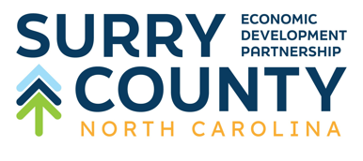 | Investment  Pledge  Form

Name:
Company:
Address:
Phone Number:
Email Address:
To strengthen the Surry County economy by supporting Surry County Economic Development Partnership’s mission to provide a network of coordinated resources for economic development that will grow, support, and maintain the well-being of the communities, businesses, and investors of Surry County, we hereby authorize and commit the following investment towards these five-year initiatives:
Campaign Levels:

Founders | $20,000 annually
Platinum | $10,000 annually
Gold |$5,000 annually
Silver | $3,000 annually
Bronze | $1,000 annually
Friends of the EDP | $500 annually

Total 5-year Pledge: $_________________________
Initial Payment: $ _ _ _______ Annual: Yr: 2025
Payment 2: $ _ ___ ___ _____ Annual: Yr: 2026
Payment 3: $ _ ______ ____ Annual: Yr: 2027
Payment 4: $ ______ _____ Annual: Yr: 2028
Payment 5: $ _ ______ _______ Annual: Yr: 2029
Signature: ___________________________________Date: ___________________________
Preferred billing reminder month: _____ __________________ _______________
Contact for invoicing: Name: ______________________ Title: _________________________
Email Address ________________________________________________________________
Direct Phone Number: __________________________________________________________
Address: _____________________________________________________________________
*Surry County Economic Development Partnership a 501(c)6 non-profit organization and your support may be treated as a necessary and ordinary business expense.*

Please scan and email to:
blake@surryedp.com

Or Return Completed Form To: Surry County Economic Development Partnership 190 Virginia Ave. Mount Airy, NC 27030

